ASSIGNMENT NO: 2
Network Lab Experiments

Name: Goutham Krishna
Class: S5, CSE A
Roll No: 32
Date: 08-08-2026

Experiment 1: Hello – Client/Server Communication

Aim
To design and implement a simple TCP client–server program in C, where the client establishes a connection with the server, transmits a greeting message, and the server reads and echoes back an acknowledgement.

Commands Used
gcc server.c -o server gcc client.c -o client
./server (Terminal 1)
./client (Terminal 2)

Procedure

Client Code
#include <stdio.h> #include <string.h> #include <unistd.h> #include <arpa/inet.h> #include <sys/socket.h>

#define SERVER_PORT 9090
#define MAX_BUF 512

int main() {
int sockfd;
struct sockaddr_in serv_addr; char buf[MAX_BUF];
char *greet = "Hi Server, this is the client!";

sockfd = socket(AF_INET, SOCK_STREAM, 0); if (sockfd < 0) {
perror("Could not create socket"); return 1;
}

memset(&serv_addr, 0, sizeof(serv_addr)); serv_addr.sin_family = AF_INET; serv_addr.sin_port = htons(SERVER_PORT);
inet_pton(AF_INET, "127.0.0.1", &serv_addr.sin_addr);

if (connect(sockfd, (struct sockaddr *)&serv_addr, sizeof(serv_addr)) < 0) { perror("Connection to server failed");
return 1;
}

write(sockfd, greet, strlen(greet)); printf("Client sent: %s\n", greet);

int n = read(sockfd, buf, MAX_BUF - 1); buf[n] = '\0';
printf("Server replied: %s\n", buf);

close(sockfd); return 0;
}

Server Code
#include <stdio.h> #include <string.h> #include <unistd.h> #include <arpa/inet.h> #include <sys/socket.h>

#define SERVER_PORT 9090
#define MAX_BUF 512

int main() {
int listen_fd, conn_fd;
struct sockaddr_in serv_addr, cli_addr; socklen_t cli_len = sizeof(cli_addr); char buf[MAX_BUF];

listen_fd = socket(AF_INET, SOCK_STREAM, 0); int opt = 1;
setsockopt(listen_fd, SOL_SOCKET, SO_REUSEADDR, &opt, sizeof(opt));

memset(&serv_addr, 0, sizeof(serv_addr)); serv_addr.sin_family = AF_INET; serv_addr.sin_addr.s_addr = INADDR_ANY; serv_addr.sin_port = htons(SERVER_PORT);

bind(listen_fd, (struct sockaddr *)&serv_addr, sizeof(serv_addr)); listen(listen_fd, 5);
printf("Server listening on port %d...\n", SERVER_PORT);

conn_fd = accept(listen_fd, (struct sockaddr *)&cli_addr, &cli_len); printf("Client connected: %s\n", inet_ntoa(cli_addr.sin_addr));

int n = read(conn_fd, buf, MAX_BUF - 1); buf[n] = '\0';
printf("Received from client: %s\n", buf);

char *reply = "Hello Client, message received!"; write(conn_fd, reply, strlen(reply));

close(conn_fd); close(listen_fd); return 0;
}

Sample Output
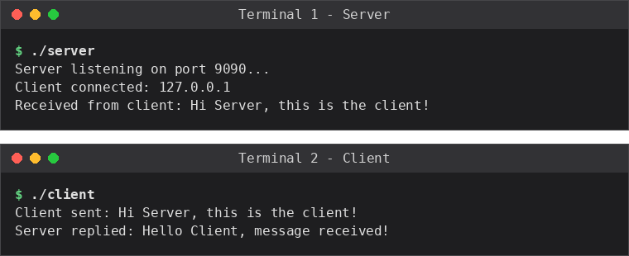

Result
The TCP client–server program was implemented and executed successfully. The client was able to connect to the server, send a greeting message, and receive a reply, confirming that a reliable two-way byte stream was established using sockets.

Experiment 2: Arithmetic Server

Aim
To implement a client–server application in which the client sends two integers and an operator to the server, and the server performs the requested arithmetic operation and returns the result to the client.

Commands Used
gcc arith_server.c -o arith_server gcc arith_client.c -o arith_client
./arith_server (Terminal 1)
./arith_client (Terminal 2)

Procedure

Client Code
#include <stdio.h> #include <string.h> #include <unistd.h> #include <arpa/inet.h> #include <sys/socket.h>
#define PORT 9091 int main() {
int sockfd;
struct sockaddr_in serv_addr; char request[100], response[100]; int a, b;
char op;

sockfd = socket(AF_INET, SOCK_STREAM, 0); serv_addr.sin_family = AF_INET; serv_addr.sin_port = htons(PORT);
inet_pton(AF_INET, "127.0.0.1", &serv_addr.sin_addr); connect(sockfd, (struct sockaddr *)&serv_addr, sizeof(serv_addr));

printf("Enter first number, operator, second number (e.g. 12 + 7): "); scanf("%d %c %d", &a, &op, &b);

sprintf(request, "%d %c %d", a, op, b); write(sockfd, request, strlen(request));

int n = read(sockfd, response, sizeof(response) - 1); response[n] = '\0';
printf("Result from server: %s\n", response);

close(sockfd); return 0;
}

Server Code
#include <stdio.h> #include <string.h> #include <unistd.h> #include <arpa/inet.h> #include <sys/socket.h>
#define PORT 9091 int main() {
int listen_fd, conn_fd;
struct sockaddr_in serv_addr, cli_addr; socklen_t cli_len = sizeof(cli_addr); char buf[100], result[100];
int a, b;

char op;

listen_fd = socket(AF_INET, SOCK_STREAM, 0); int opt = 1;
setsockopt(listen_fd, SOL_SOCKET, SO_REUSEADDR, &opt, sizeof(opt));

serv_addr.sin_family = AF_INET; serv_addr.sin_addr.s_addr = INADDR_ANY; serv_addr.sin_port = htons(PORT);

bind(listen_fd, (struct sockaddr *)&serv_addr, sizeof(serv_addr)); listen(listen_fd, 5);
printf("Arithmetic server listening on port %d...\n", PORT);
conn_fd = accept(listen_fd, (struct sockaddr *)&cli_addr, &cli_len); int n = read(conn_fd, buf, sizeof(buf) - 1);
buf[n] = '\0';
sscanf(buf, "%d %c %d", &a, &op, &b); printf("Received expression: %s\n", buf);

int res = 0; switch (op) {
case '+': res = a + b; break; case '-': res = a - b; break; case '*': res = a * b; break; case '/':
if (b != 0) res = a / b;
else { write(conn_fd, "Error: div by 0", 15); close(conn_fd); return 1; } break;
default:
write(conn_fd, "Error: bad operator", 20); close(conn_fd);
return 1;
}

sprintf(result, "%d %c %d = %d", a, op, b, res); write(conn_fd, result, strlen(result));

close(conn_fd); close(listen_fd); return 0;
}

Sample Output
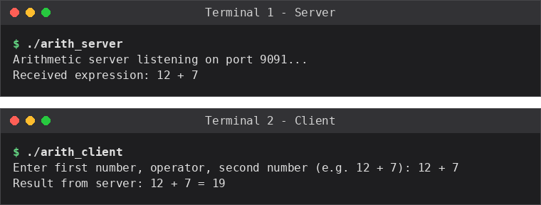

Result
The arithmetic server correctly parsed the expression sent by the client, computed the requested operation (+, -, *, /), and returned the formatted result, demonstrating request–response processing over TCP sockets.

Experiment 3: String Processing Server

Aim
To implement a client–server program in which the client sends a text string to the server, and the server processes the string (reverses it, converts it to uppercase, and counts its characters) before returning the results to the client.

Commands Used
gcc str_server.c -o str_server gcc str_client.c -o str_client
./str_server (Terminal 1)
./str_client (Terminal 2)

Procedure

Client Code
#include <stdio.h> #include <string.h> #include <unistd.h> #include <arpa/inet.h> #include <sys/socket.h>

#define PORT 9092
#define BUF_SIZE 256

int main() {
int sockfd;
struct sockaddr_in serv_addr;
char sendbuf[BUF_SIZE], recvbuf[BUF_SIZE];

sockfd = socket(AF_INET, SOCK_STREAM, 0); serv_addr.sin_family = AF_INET; serv_addr.sin_port = htons(PORT);
inet_pton(AF_INET, "127.0.0.1", &serv_addr.sin_addr); connect(sockfd, (struct sockaddr *)&serv_addr, sizeof(serv_addr));

printf("Enter a string to send to server: "); fgets(sendbuf, BUF_SIZE, stdin); sendbuf[strcspn(sendbuf, "\n")] = '\0';

write(sockfd, sendbuf, strlen(sendbuf));

int n = read(sockfd, recvbuf, BUF_SIZE - 1); recvbuf[n] = '\0';
printf("Server response:\n%s\n", recvbuf);

close(sockfd); return 0;
}

Server Code
#include <stdio.h> #include <string.h> #include <ctype.h> #include <unistd.h> #include <arpa/inet.h> #include <sys/socket.h>

#define PORT 9092
#define BUF_SIZE 256

void reverse_str(char *src, char *dest) { int len = strlen(src);
for (int i = 0; i < len; i++)

dest[i] = src[len - 1 - i];
dest[len] = '\0';
}

int main() {
int listen_fd, conn_fd;
struct sockaddr_in serv_addr, cli_addr; socklen_t cli_len = sizeof(cli_addr);
char buf[BUF_SIZE], rev[BUF_SIZE], upper[BUF_SIZE], result[BUF_SIZE * 4];

listen_fd = socket(AF_INET, SOCK_STREAM, 0); int opt = 1;
setsockopt(listen_fd, SOL_SOCKET, SO_REUSEADDR, &opt, sizeof(opt));

serv_addr.sin_family = AF_INET; serv_addr.sin_addr.s_addr = INADDR_ANY; serv_addr.sin_port = htons(PORT);

bind(listen_fd, (struct sockaddr *)&serv_addr, sizeof(serv_addr)); listen(listen_fd, 5);
printf("String server listening on port %d...\n", PORT);
conn_fd = accept(listen_fd, (struct sockaddr *)&cli_addr, &cli_len); int n = read(conn_fd, buf, BUF_SIZE - 1);
buf[n] = '\0';
printf("Received string: %s\n", buf);

reverse_str(buf, rev); strcpy(upper, buf);
for (int i = 0; upper[i]; i++) upper[i] = toupper(upper[i]);

sprintf(result, "Original : %s\nReversed : %s\nUppercase: %s\nLength : %d", buf, rev, upper, (int)strlen(buf));

write(conn_fd, result, strlen(result));

close(conn_fd); close(listen_fd); return 0;
}

Sample Output
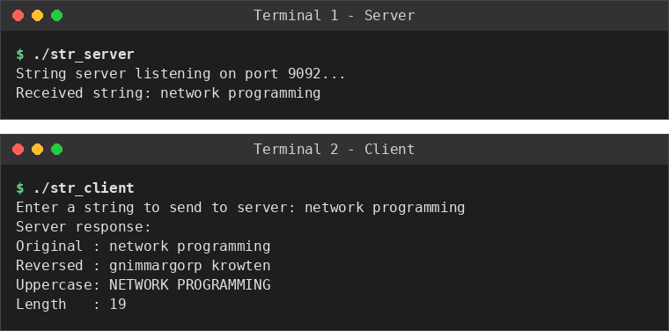

Result

The server successfully received the client's string and returned its reverse, uppercase form, and character count, demonstrating basic text processing carried out on the server side of a socket connection.

Experiment 4: Array Processing Server

Aim
To implement a client–server program in which the client sends an array of integers to the server, and the server computes and returns the sum, average, maximum, and minimum of the array elements, along with the sorted array.

Commands Used
gcc arr_server.c -o arr_server gcc arr_client.c -o arr_client
./arr_server (Terminal 1)
./arr_client (Terminal 2)

Procedure

Client Code
#include <stdio.h> #include <string.h> #include <unistd.h> #include <arpa/inet.h> #include <sys/socket.h>

#define PORT 9093
#define BUF_SIZE 512

int main() {
int sockfd;
struct sockaddr_in serv_addr;
char sendbuf[BUF_SIZE], recvbuf[BUF_SIZE]; int n, arr[50], pos = 0;

sockfd = socket(AF_INET, SOCK_STREAM, 0); serv_addr.sin_family = AF_INET; serv_addr.sin_port = htons(PORT);
inet_pton(AF_INET, "127.0.0.1", &serv_addr.sin_addr); connect(sockfd, (struct sockaddr *)&serv_addr, sizeof(serv_addr));

printf("How many elements? "); scanf("%d", &n);
printf("Enter %d integers: ", n);

pos += sprintf(sendbuf + pos, "%d", n); for (int i = 0; i < n; i++) {
scanf("%d", &arr[i]);
pos += sprintf(sendbuf + pos, " %d", arr[i]);
}

write(sockfd, sendbuf, strlen(sendbuf));

int len = read(sockfd, recvbuf, BUF_SIZE - 1); recvbuf[len] = '\0';
printf("Server response:\n%s\n", recvbuf);

close(sockfd); return 0;
}

Server Code
#include <stdio.h> #include <string.h> #include <unistd.h> #include <arpa/inet.h> #include <sys/socket.h> #define PORT 9093

#define BUF_SIZE 512

int main() {
int listen_fd, conn_fd;
struct sockaddr_in serv_addr, cli_addr; socklen_t cli_len = sizeof(cli_addr); char buf[BUF_SIZE], result[BUF_SIZE]; int arr[50], n;

listen_fd = socket(AF_INET, SOCK_STREAM, 0); int opt = 1;
setsockopt(listen_fd, SOL_SOCKET, SO_REUSEADDR, &opt, sizeof(opt));

serv_addr.sin_family = AF_INET; serv_addr.sin_addr.s_addr = INADDR_ANY; serv_addr.sin_port = htons(PORT);

bind(listen_fd, (struct sockaddr *)&serv_addr, sizeof(serv_addr)); listen(listen_fd, 5);
printf("Array server listening on port %d...\n", PORT);
conn_fd = accept(listen_fd, (struct sockaddr *)&cli_addr, &cli_len); int len = read(conn_fd, buf, BUF_SIZE - 1);
buf[len] = '\0';

char *tok = strtok(buf, " "); n = atoi(tok);
for (int i = 0; i < n; i++) { tok = strtok(NULL, " "); arr[i] = atoi(tok);
}
printf("Received %d elements\n", n);

int sum = 0, mx = arr[0], mn = arr[0]; for (int i = 0; i < n; i++) {
sum += arr[i];
if (arr[i] > mx) mx = arr[i];
if (arr[i] < mn) mn = arr[i];
}
float avg = (float)sum / n;

/* simple bubble sort for the sorted-array output */ int sorted[50];
memcpy(sorted, arr, n * sizeof(int)); for (int i = 0; i < n - 1; i++)
for (int j = 0; j < n - 1 - i; j++) if (sorted[j] > sorted[j + 1]) {
int t = sorted[j]; sorted[j] = sorted[j + 1]; sorted[j + 1] = t;
}

int pos = sprintf(result, "Sum = %d\nAverage = %.2f\nMax = %d\nMin = %d\nSorted =", sum, avg, mx, mn);
for (int i = 0; i < n; i++)
pos += sprintf(result + pos, " %d", sorted[i]); write(conn_fd, result, strlen(result));
close(conn_fd); close(listen_fd); return 0;
}

Sample Output
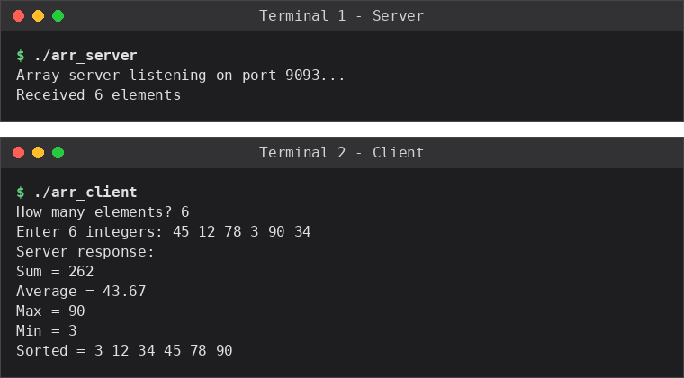

Result
The server correctly computed the sum, average, maximum, minimum, and sorted order of the integer array sent by the client, showing how variable-length data can be serialized, transmitted, and processed over a TCP connection.

Experiment 5: Matrix Analyzer

Aim
To implement a client–server program in which the client sends a square matrix to the server, and the server computes its transpose, trace, and the sum of all elements, returning the results to the client.

Commands Used
gcc mat_server.c -o mat_server gcc mat_client.c -o mat_client
./mat_server (Terminal 1)
./mat_client (Terminal 2)

Procedure

Client Code
#include <stdio.h> #include <string.h> #include <unistd.h> #include <arpa/inet.h> #include <sys/socket.h>

#define PORT 9094
#define BUF_SIZE 1024

int main() {
int sockfd;
struct sockaddr_in serv_addr;
char sendbuf[BUF_SIZE], recvbuf[BUF_SIZE]; int n, mat[10][10], pos = 0;

sockfd = socket(AF_INET, SOCK_STREAM, 0); serv_addr.sin_family = AF_INET; serv_addr.sin_port = htons(PORT);
inet_pton(AF_INET, "127.0.0.1", &serv_addr.sin_addr); connect(sockfd, (struct sockaddr *)&serv_addr, sizeof(serv_addr));

printf("Enter size of square matrix (n): "); scanf("%d", &n);
printf("Enter %d elements row-wise:\n", n * n);

pos += sprintf(sendbuf + pos, "%d", n); for (int i = 0; i < n; i++)
for (int j = 0; j < n; j++) { scanf("%d", &mat[i][j]);
pos += sprintf(sendbuf + pos, " %d", mat[i][j]);
}

write(sockfd, sendbuf, strlen(sendbuf));

int len = read(sockfd, recvbuf, BUF_SIZE - 1); recvbuf[len] = '\0';
printf("Server response:\n%s\n", recvbuf);

close(sockfd); return 0;
}

Server Code
#include <stdio.h> #include <string.h> #include <unistd.h> #include <arpa/inet.h> #include <sys/socket.h>

#define PORT 9094

#define BUF_SIZE 1024

int main() {
int listen_fd, conn_fd;
struct sockaddr_in serv_addr, cli_addr; socklen_t cli_len = sizeof(cli_addr); char buf[BUF_SIZE], result[BUF_SIZE]; int mat[10][10], trans[10][10], n;

listen_fd = socket(AF_INET, SOCK_STREAM, 0); int opt = 1;
setsockopt(listen_fd, SOL_SOCKET, SO_REUSEADDR, &opt, sizeof(opt));

serv_addr.sin_family = AF_INET; serv_addr.sin_addr.s_addr = INADDR_ANY; serv_addr.sin_port = htons(PORT);

bind(listen_fd, (struct sockaddr *)&serv_addr, sizeof(serv_addr)); listen(listen_fd, 5);
printf("Matrix server listening on port %d...\n", PORT);
conn_fd = accept(listen_fd, (struct sockaddr *)&cli_addr, &cli_len); int len = read(conn_fd, buf, BUF_SIZE - 1);
buf[len] = '\0';

char *tok = strtok(buf, " "); n = atoi(tok);
for (int i = 0; i < n; i++)
for (int j = 0; j < n; j++) { tok = strtok(NULL, " "); mat[i][j] = atoi(tok);
}
printf("Received %dx%d matrix\n", n, n);

int sum = 0, trace = 0;
for (int i = 0; i < n; i++)
for (int j = 0; j < n; j++) { trans[j][i] = mat[i][j]; sum += mat[i][j];
if (i == j) trace += mat[i][j];
}

int pos = sprintf(result, "Sum = %d\nTrace = %d\nTranspose:\n", sum, trace); for (int i = 0; i < n; i++) {
for (int j = 0; j < n; j++)
pos += sprintf(result + pos, "%d ", trans[i][j]); pos += sprintf(result + pos, "\n");
}

write(conn_fd, result, strlen(result));

close(conn_fd); close(listen_fd); return 0;
}

Sample Output
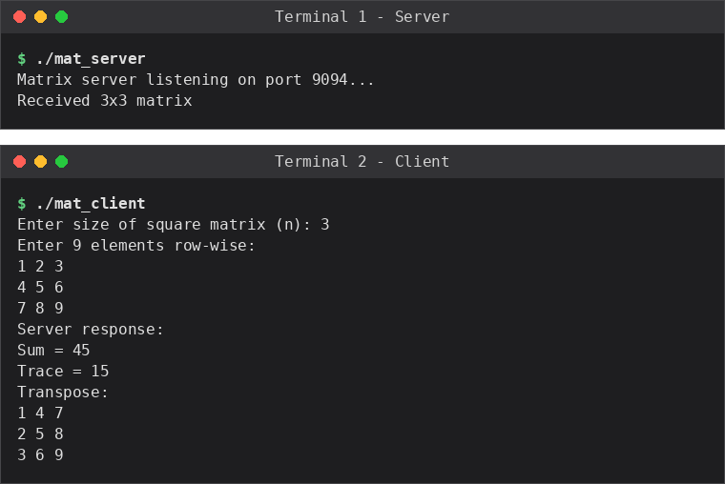

Result
The server successfully computed the sum, trace, and transpose of the square matrix sent by the client, illustrating how structured multi-dimensional data can be flattened for transmission and reconstructed and processed on the server side.

